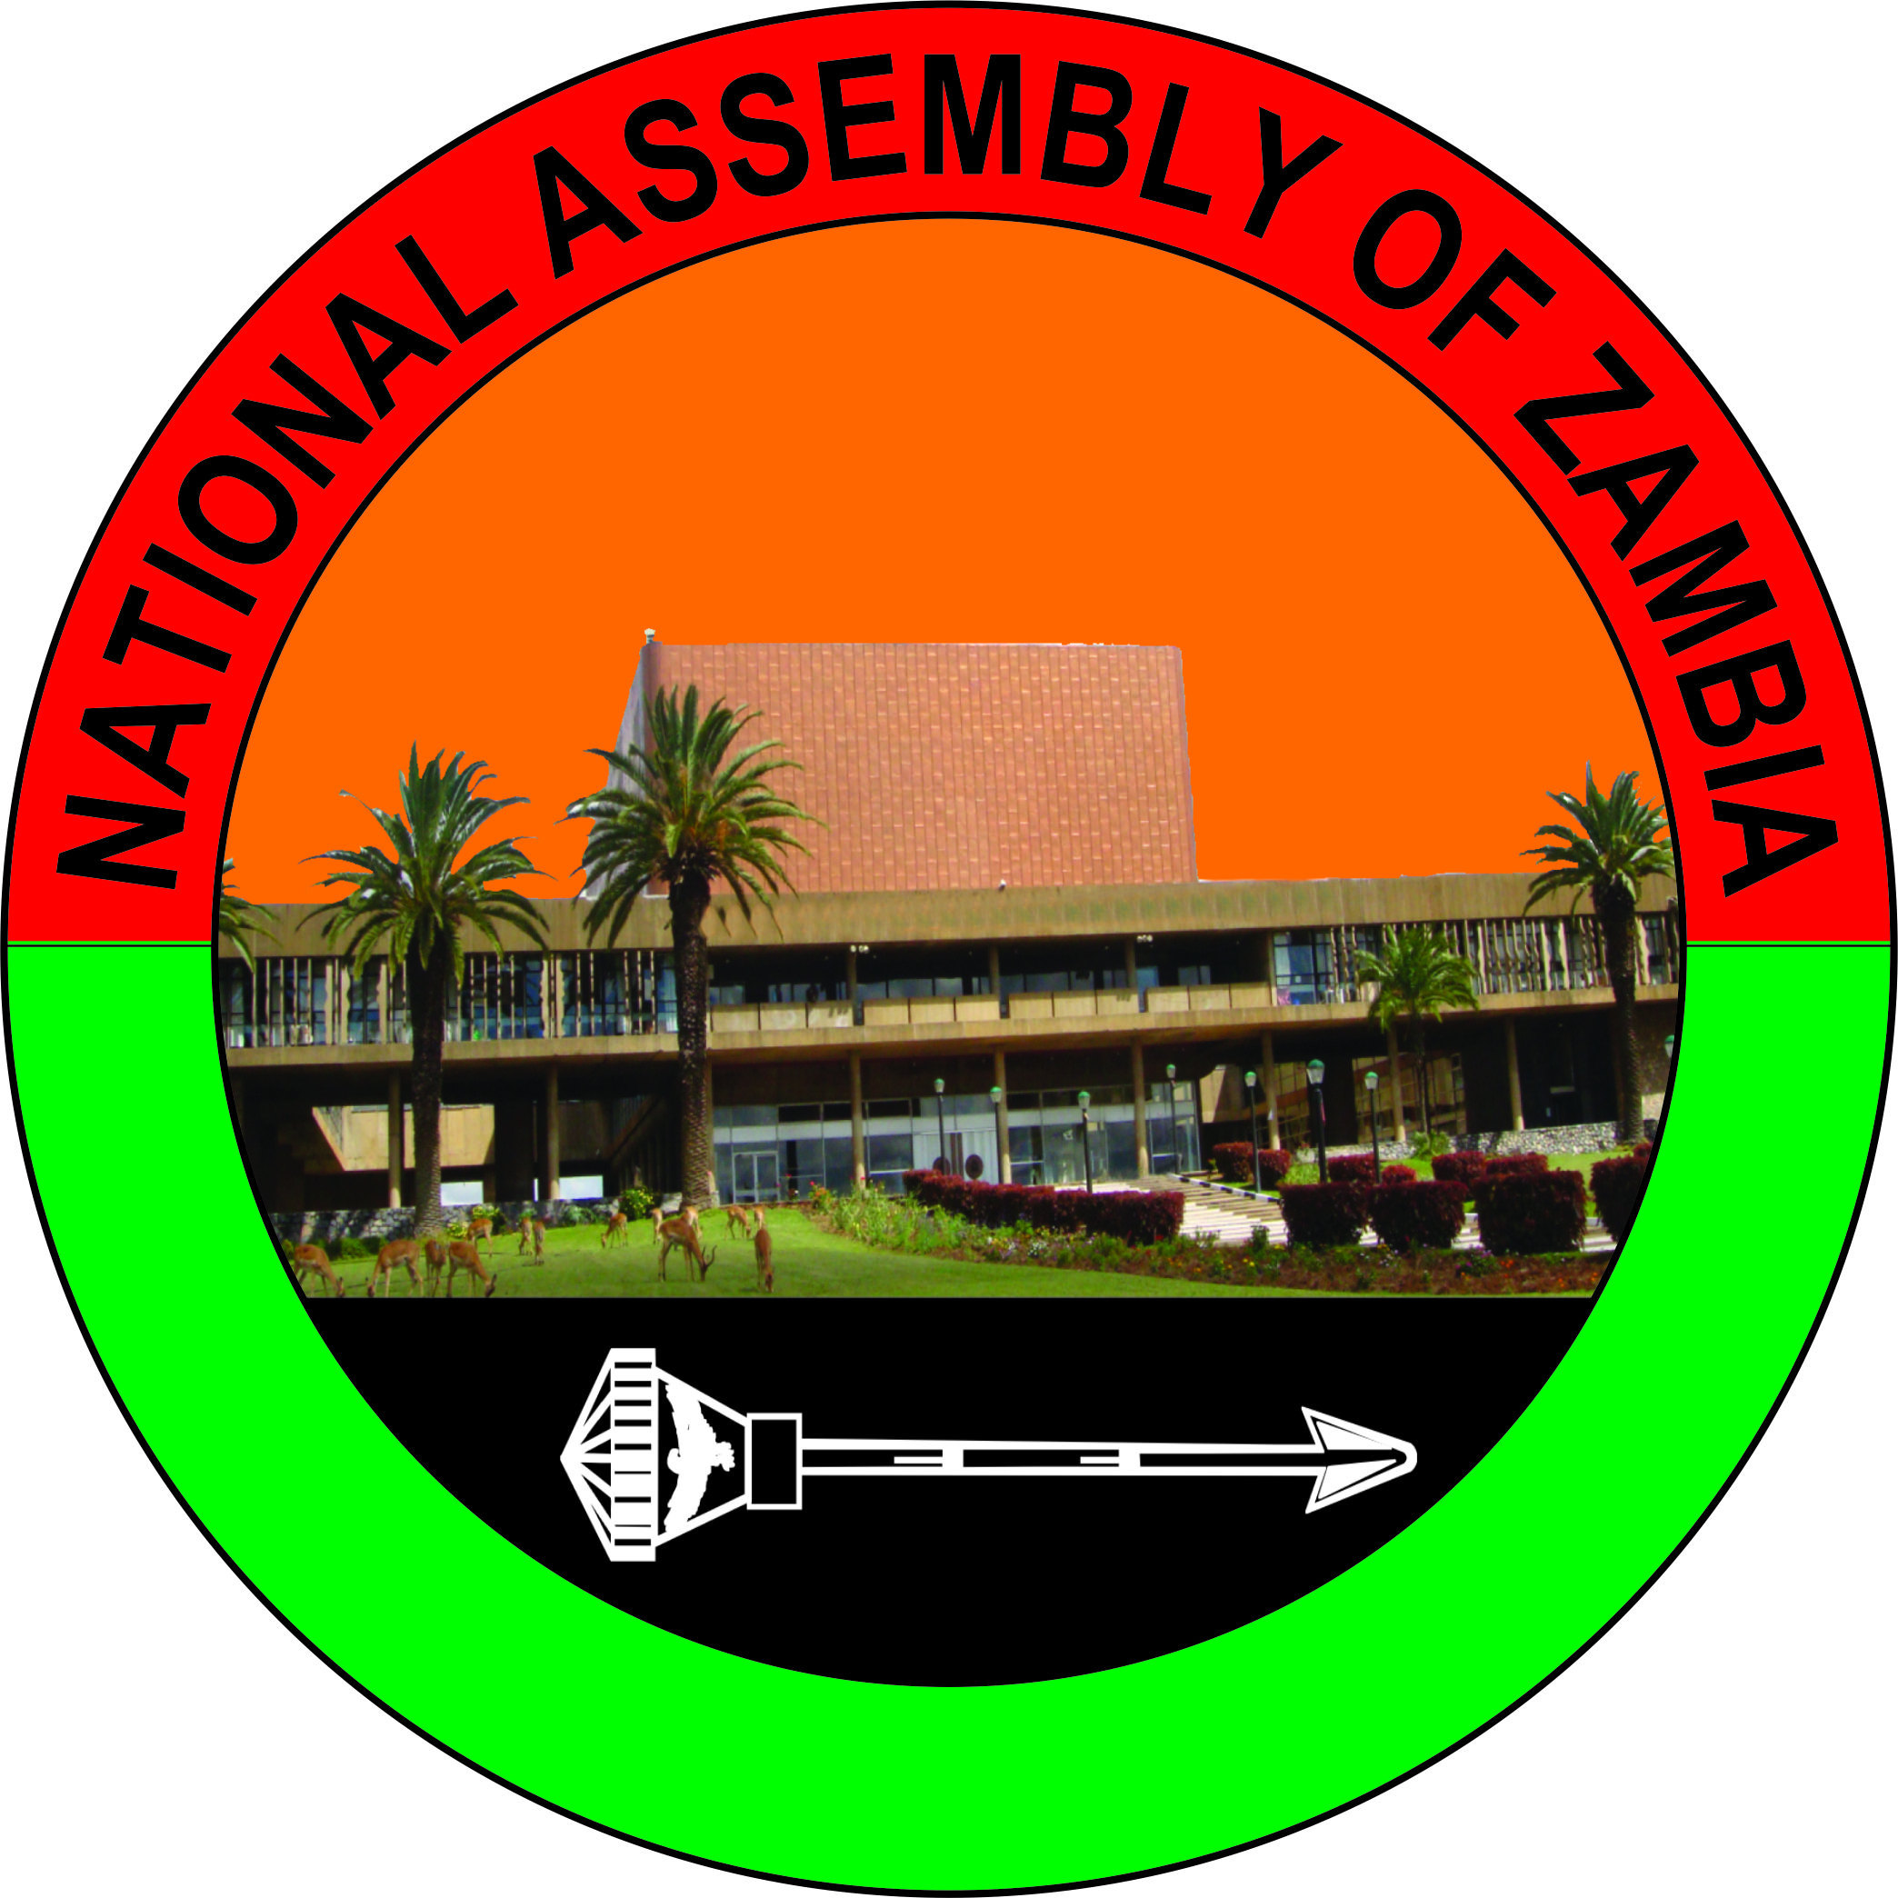

STATEMENT BY THE RIGHT HONOURABLE NELLY BK MUTTI, SC, MP, FAPRA, SPEAKER OF THE NATIONAL ASSEMBLY OF ZAMBIA ON THE COMMEMORATION OF THE 2025 INTERNATIONAL WOMEN’S DAY UNDER THE THEME, “FOR ALL WOMEN AND GIRLS: RIGHTS, EQUALITY, EMPOWERMENT.”

For release, 8th March, 2025

The National Assembly of Zambia (NAZ) joins the rest of the country, and the rest of the world in commemorating this year’s International Women’s Day, being held under the theme, “For all Women and Girls: Rights, Equality, Empowerment.” This theme calls for action to unlock women’s potential and achieve equal rights, power and opportunities for all, especially the women and girls who have, for a long time being marginalised.

Country Men and Women,

You may wish to note that this year’s celebrations coincide with the 30thanniversary of the Beijing Declaration and Platform for Action, which is considered to be the most progressive and widely endorsed blueprint for advancing women’s and girls’ rights.

It is noteworthy that, 30 years after the Declaration, significant progress has been made, in particular through the enactment of legislation that protects women and girls from different forms of violence and abuse. Further, legislation has been enacted to ban discrimination from employment on the basis of gender, which is contributing to women empowerment.

From a national perspective, our legal framework has been strengthened to promote gender equality and the empowerment of women and girls. Specifically, through the Constitution (Amendment) Act No. 2 of 2016, the equal worth of women and men and their rights to freely participate in, determine and build a sustainable political, legal, economic and social order, has been affirmed. Additionally, the enacted Gender Equity and Equality Act, No. 22 of 2015, further strengthens the legal framework for the elimination of all forms of discrimination against women and girls; and domesticating, among others, the Convention on the Elimination of all Forms of Discrimination against Women.

Country Men and Women,

Despite the notable progress, particularly, in legislation, both at global and national levels, it is ironic that gender inequality still remains pervasive. For example, regarding economic empowerment, the United Nations reports that worldwide, around 2.4 billion women of working age are not afforded equal economic opportunity. In Zambia, poverty is higher among women than men, giving a clear indication of the existing inequalities in economic opportunities. Similarly, women participation in the labour force in the formal sector is low compared to men.

This speaks to the fact that, although legislation has been enacted, there is weak implementation, not only in Zambia, but, world over. Therefore, this year’s theme is calling for all stakeholders to not only give ‘lip service’ but “ACT NOW,” in promoting women’s and girls’ rights and gender equality. Ultimately, achieving gender equality is not only a fundamental right, it also has immense economic and social dividends. This is in line with the sentiments of the United Nations Secretary General, Antonio Guterres, in his message during the 2024International Women’s Day, when he stated that, “Women’s rights are a proven path to fair, peaceful, prosperous societies. It is good for us all. Together, let’s take urgent action to make it a reality.”

In view of the foregoing, and in keeping with the spirit of “ACTING NOW,” let me take this opportunity to urge all stakeholders – the Government, development partners, civil society, women’s organisations, young people, the private sector and the media, to concertedly work together to ensure rights, equality and empowerment for all women and girls. We must all “ACT NOW” in creating a world, and a Zambia, in particular where women and girls have full and equal rights in every respect and can achieve their full potential.

Country Men and Women,

As a Legislature, the number of female Members of Parliament, which stands at 25 out of 167 Members of Parliament, translating into 15%, remains a serious concern, given its Legislative, Representative and Oversight Functions. With the anticipated amendment of the Constitution on non contentious issues, it is my expectation that we shall entrench a quota system that will guarantee more women in the People’s House.

Country Men and Women,

With these remarks, I wish you all a Happy International Women’s Day, and I thank you.

Rt Hon Ms Nelly B K Mutti, SC, MP, FAPRA
SPEAKER OF THE NATIONAL ASSEMBLY OF ZAMBIA
National Assembly of Zambia, Parliament Buildings, Olympia Park, P O Box 31299, Lusaka

_______________________________

